Michael Lee

HW #3

Perceptron

1.

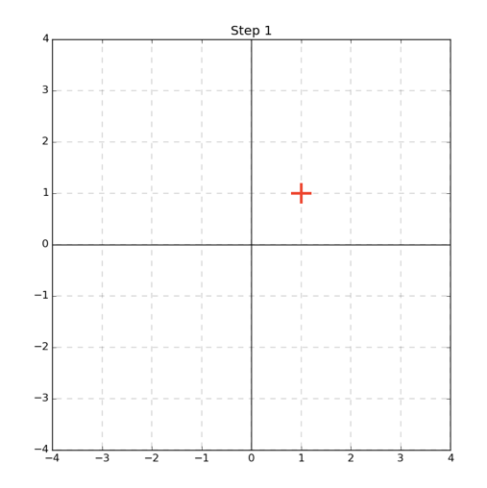





2. Our learned perceptron does not draw the maximized margin. We see that if we pick the line x[2]=0 we get a maximized margin of 1.

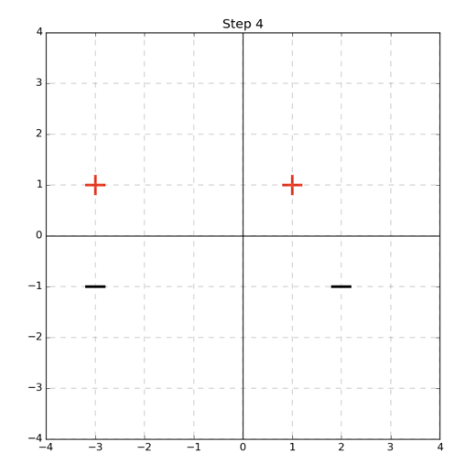

3.

Max Mistakes = ${\left(\frac{γ}{R}\right)}^{2}={\left(\frac{5}{0.5}\right)}^{2}=100$

SVMs: Hinge Loss and Mistake Bounds

1.

Here we see that the function is convex because if we take any two points (as shown in the orange) that any line we draw.

2. For a fixed $w$ we take on the values 0,1 because we regularize w such that

3. We consider the bound in two cases:

-In the best case M(w) equals 0 and the classification is therefore 0.

So we have:

$0≤\frac{1}{N}\sum_{i=1}^{N}{max⁡[0,1-yw^{T}x]}$

We can observe that the minimum value of $\frac{1}{N}\sum_{i=1}^{N}{max⁡[0,1-yw^{T}x]}$ would be for the function $max⁡[0,1-yw^{T}x]$ to return 0. And hence we would get-> $0≤0$ so the upper bound holds.

-In the best case M(w) equals N we have:

$\frac{N}{N}≤\frac{1}{N}\sum_{i=1}^{N}{max⁡[0,1-yw^{T}x]}$

**Kernel Functions and Linear Separability**

${\left(x\left[1\right]-a\right)}^{2}+{\left(x\left[2\right]-b\right)}^{2}-r^{2}=0$

$$x{\left[1\right]}^{2}-2x\left[1\right]a+a^{2}+x{\left[2\right]}^{2}-2x\left[2\right]b+b^{2}-r^{2}=0$$

We recognize that the vector of our 4-dimesional plane has coefficients (-2a,-2b,1,1).